# Scripts and Modules

## Exercises

### Week 5

Prior to attempting these exercises ensure you have read the lecture notes and/or viewed the video, and followed the practical. You may wish to use the Python interpreter in interactive mode to help work out the solutions to some of the questions.

Download and store this document within your own filespace, so the contents can be edited. You will be able to refer to it during the test in Week 6.

Enter your answers directly into the highlighted boxes.

For more information about the module delivery, assessment and feedback please refer to the module within the MyBeckett portal.

**_________________________________________________________________________**

## ©2021 Mark Dixon / Tony Jenkins

**_________________________________________________________________________**

When a Python program is stored within a text file (i.e. a *script*), what suffix should be used for the filename?

*Answer:*

.py

**_________________________________________________________________________**

Is it necessary to use a special Integrated Development Environment (IDE) to write Python code in text files?

*Answer:*

No. Any text editor will work fine

**_________________________________________________________________________**

When a *script* is executed from a file, are the results of evaluating expressions automatically displayed on the screen without the need of a print() function call?

*Answer:*

No, the print() function is necessary

**_________________________________________________________________________**

What command would need to be typed in an operating system terminal window in order to execute a Python script called PrintNames.py?

*Answer:*

python PrintNames.py

What command would need to be typed in a terminal in order to pass the values "John", "Eric", "Graham" as *command line arguments* to the PrintNames.py script?

*Answer:*

python PrintNames.py John Eric Graham

**_________________________________________________________________________**

When a Python script wishes to access *command line arguments*, what **module** needs to be imported?

*Answer:*

sys module

**_________________________________________________________________________**

What is the data-type of the sys.argv variable?

*Answer:*

list

**_________________________________________________________________________**

What is stored within the first element of the sys.argv variable?

*Answer:*

Name of the script followed by .py

**_________________________________________________________________________**

Use a text editor to write the *script* called PrintNames.py. This should display any *command line arguments* that were passed during execution.

Once complete, place your solution in the answer box below.

*Answer:*

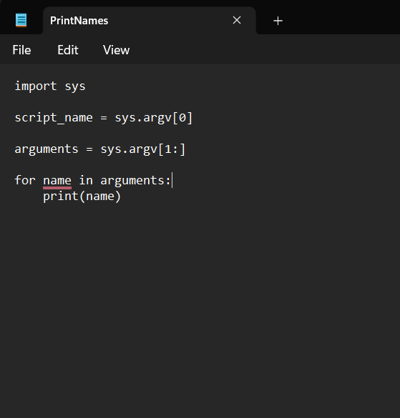

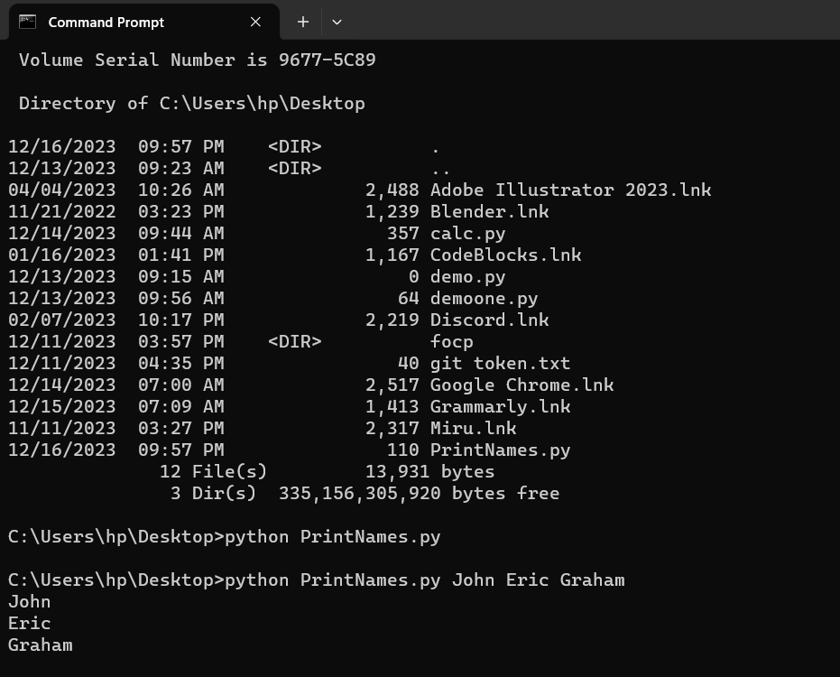

. Place your improved solution in the answer box below.

*Answer:*

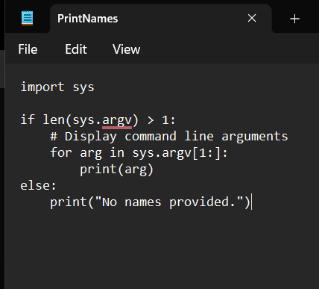

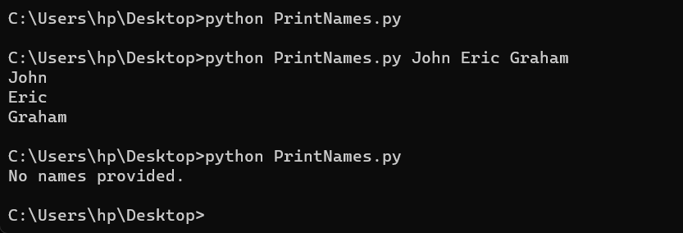

**_________________________________________________________________________**

When using an import statement, it is possible to provide an *alias* that can be used as an alternative name to access module content.

Write an **import** statement that imports the whole of the sys module, and renames it to my_system.

*Answer:*

import sys as my_system

Write a **from..import** statement that imports only the math.floor function, and renames it to lower

*Answer:*

from math import floor as lower

**_________________________________________________________________________**

What is stored in a *symbol-table*?

*Answer:*

All the information about identifiers

**_________________________________________________________________________**

Why is the following type of import statement generally not recommended?

from math import *

*Answer:*

It clutters the namespace

**_________________________________________________________________________**

When working in *interactive-mode* what convenient function can be used to list all names defined within a module?

*Answer:*

dir()

**_________________________________________________________________________**

What is the value stored within the sys.path variable used for?

*Answer:*

Module search path

**_________________________________________________________________________**

When a program is being executed as a *script* what value is assigned to the special variable __name__?

*Answer:*

__main__

What value is assigned to the __name__ variable when a program has been imported as a *module*?

*Answer:*

Name of the module

**_________________________________________________________________________**

Why is it useful for a program to be able to detect whether it is running as a *script*, or whether it has been imported as a *module*?

*Answer:*

Detects script or module import for flexibility

**_________________________________________________________________________**

## **Exercises are complete**

Save this logbook with your answers. Then ask your tutor to check your responses to each question.